**Ideation Phase**

**Define the Problem Statements**

|  |  |
| --- | --- |
| Date | 19 September 2022 |
| Team ID | PNT2022TMID30209 |
| Project Name | Real-time River Water Quality Monitoring and Control System |
| Maximum Marks | 2 Marks |

**Customer Problem Statement:**

**PS - 1**

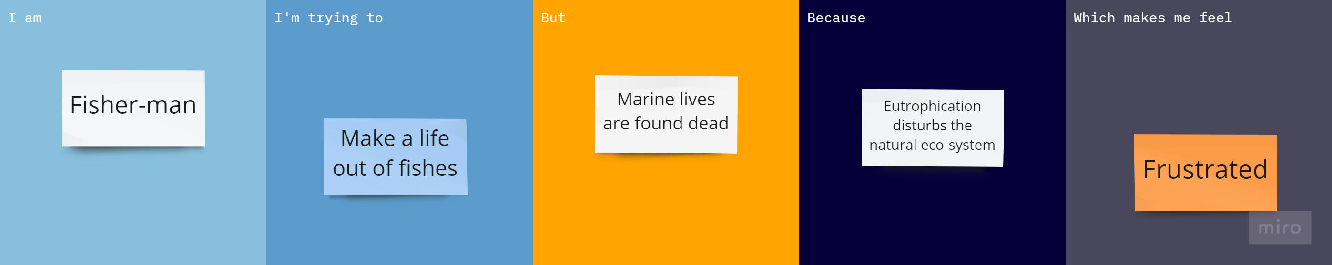

**PS – 2**

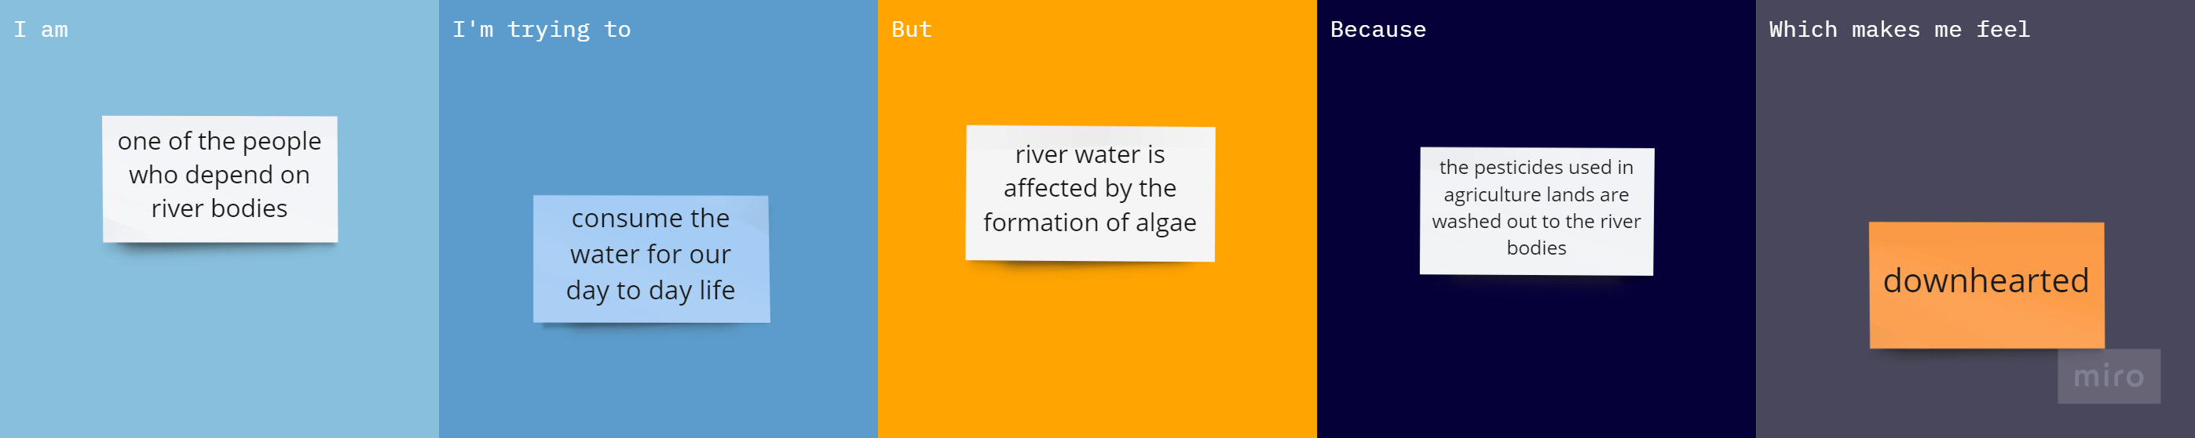

|  |  |  |  |  |  |
| --- | --- | --- | --- | --- | --- |
| **Problem Statement (PS)** | **I am (Customer)** | **I’m trying to** | **But** | **Because** | **Which makes me feel** |
| PS-1 | Fisher-man | Make a life out of fishes | Marine lives are found dead | Eutrophication disturbs the natural eco-system | Frustrated |
| PS-2 | One of the people who depends on river bodies | Consume the water for our day-to-day life | River water is affected by the formation of algae | The pesticides used in agriculture lands are washed out to the river bodies | downhearted |